Day 11 – 19/6/2025
Barghavi Bethu
112728766 – bethubal

Task 1:
What are streams?
A stream in Java is a sequence of objects that supports various methods that can be pipelined to produce the desired result. This is a sequence of elements that supports sequential and parallel operations on data. It is not a data structure but rather a view of a data source that allows user to perform operations like filtering mapping and reducing.

Task 2
What is Boilerplate code?
Lack of parallelism
Lack of Composition

Boilerplate code in java refers to the standard repeated code that we have to write in almost every java program even if it doesn’t change much it’s necessary to setup a basic program structure but doesn’t contain any special logic. Main purpose is to setup basic structure of code, and helps to compile and run properly.

Lack of parallelism: This means a program is not using multiple threads or processors efficiently and instead executes one task after another sequentially even it could be done ant the same time.

Lack of Composition: This means not using object-oriented principles properly especially by not combining smaller reusable objects to build more complex ones. Instead the code may relay too much on inheritance, duplicate logic or be structures in a rigid and less modular way.

Task 3:
List of Intermediate and terminal operations?

Intermediate operations transform the stream and return another stream. They are lazy, which means they do not do anything until a terminal operation is called.
filter()
map()
flatMap()
distinct()
sorted()
peek()
limit(n)
skip()

Terminal Operators produce a result or a side effect. They trigger the execution of the stream pipeline.
forEach()
collect()
toArray()
reduce()
count()
anyMatch()
allMatch()
findFirst()
min()
max()

Task 4:
import java.lang.FunctionalInterface;

// this is functional interface
@FunctionalInterface
interface MyInterface{

// abstract method
double getPiValue();
}

public class Main {

public static void main( String[] args ) {

// declare a reference to MyInterface
MyInterface ref;

// lambda expression
ref = () -> 3.1415;

System.out.println("Value of Pi = " + ref.getPiValue());
}
}
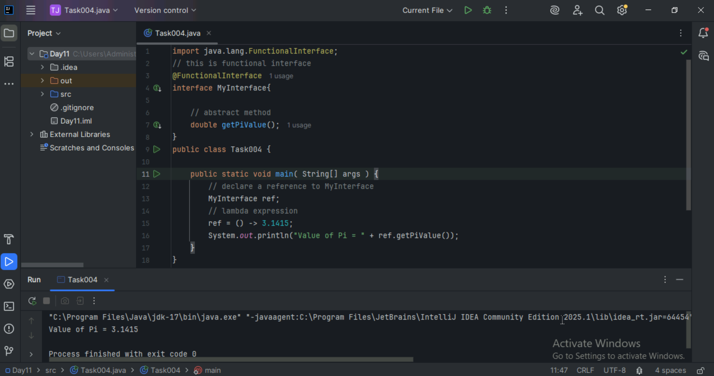

Task 5:
@FunctionalInterface
interface MyInterface {

// abstract method
String reverse(String n);
}

public class Main {

public static void main( String[] args ) {

// declare a reference to MyInterface
// assign a lambda expression to the reference
MyInterface ref = (str) -> {

String result = "";
for (int i = str.length()-1; i >= 0 ; i--)
result += str.charAt(i);
return result;
};

// call the method of the interface
System.out.println("Lambda reversed = " + ref.reverse("Lambda"));
}

}
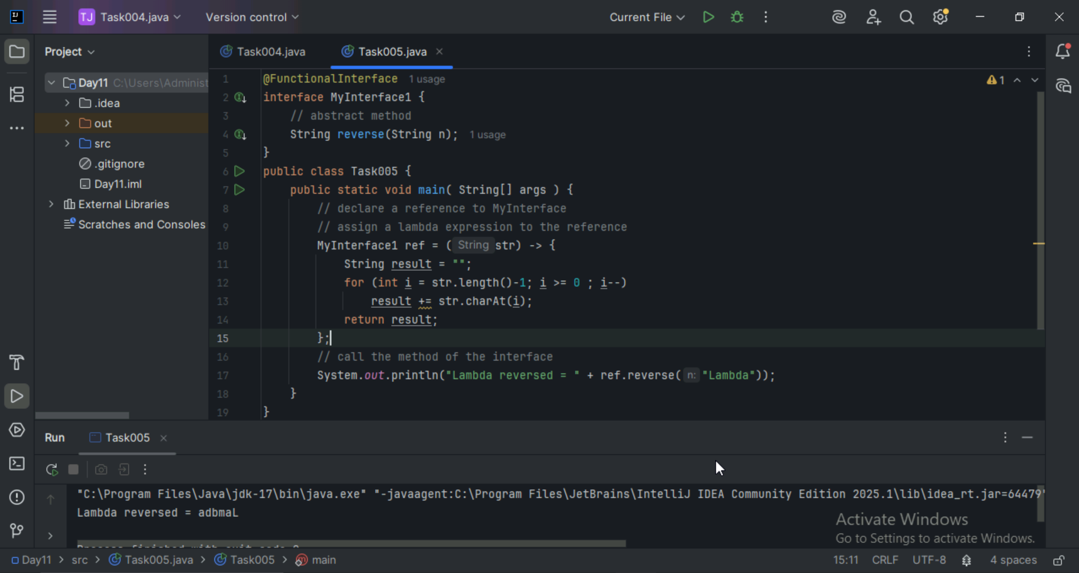

Task 6:
import java.util.ArrayList;
import java.util.List;

public class StreamMain {

// create an object of list using ArrayList
static List<String> places = new ArrayList<>();

// preparing our data
public static List getPlaces(){

// add places and country to the list
places.add("Nepal, Kathmandu");
places.add("Nepal, Pokhara");
places.add("India, Delhi");
places.add("USA, New York");
places.add("Africa, Nigeria");

return places;
}

public static void main( String[] args ) {

List<String> myPlaces = getPlaces();
System.out.println("Places from Nepal:");

// Filter places from Nepal
myPlaces.stream()
.filter((p) -> p.startsWith("Nepal"))
.map((p) -> p.toUpperCase())
.sorted()
.forEach((p) -> System.out.println(p));
}

}
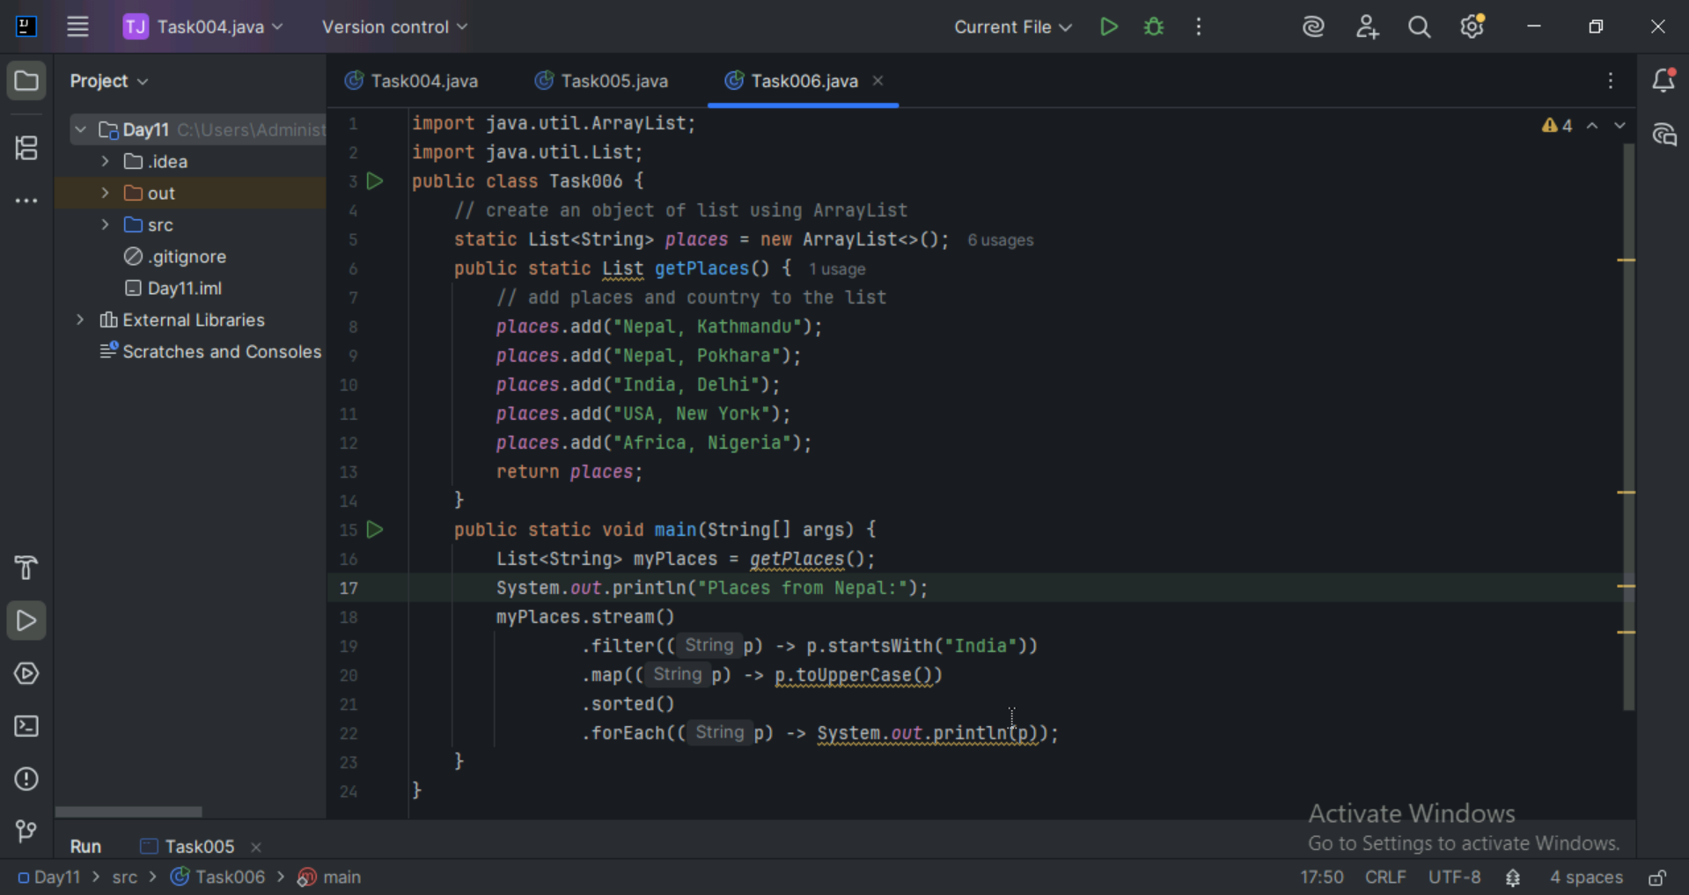
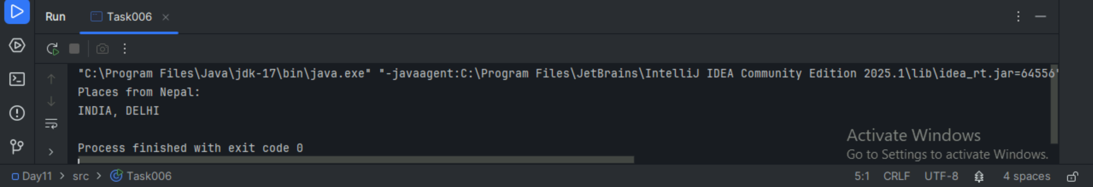

Task 7:
Write a code to create a array list to store 5 integers and display the square of each no..

Hint:

List<Integer> squareofNums = numbers.stream()
.map(num->num*num)
.collect(Collectors.toList());
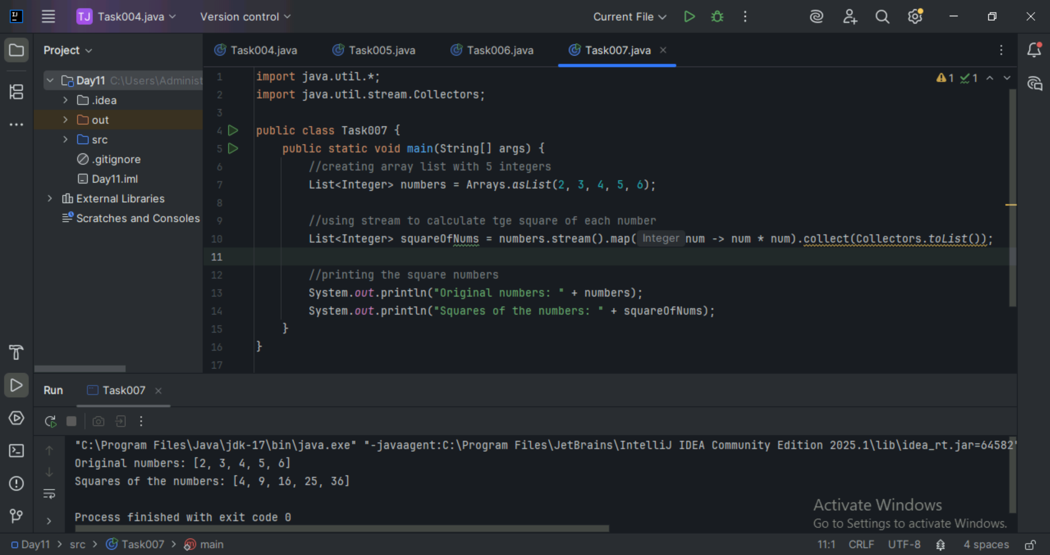

Task 8:
What do you understand by map()?

map() in java is a method used to transform each element of a stream. It takes a function as an argument. It applies that function to each element of the stream. It returns a new stream containing the transformed element.

Task 9:
Write a code to create an array list and filter the values which are odd numbers and display them..

Hint:
List<Integer> addNumbers = numbers.stream()
.filter(num -> num % 2 !=0)
.collect(Collectors.toList());
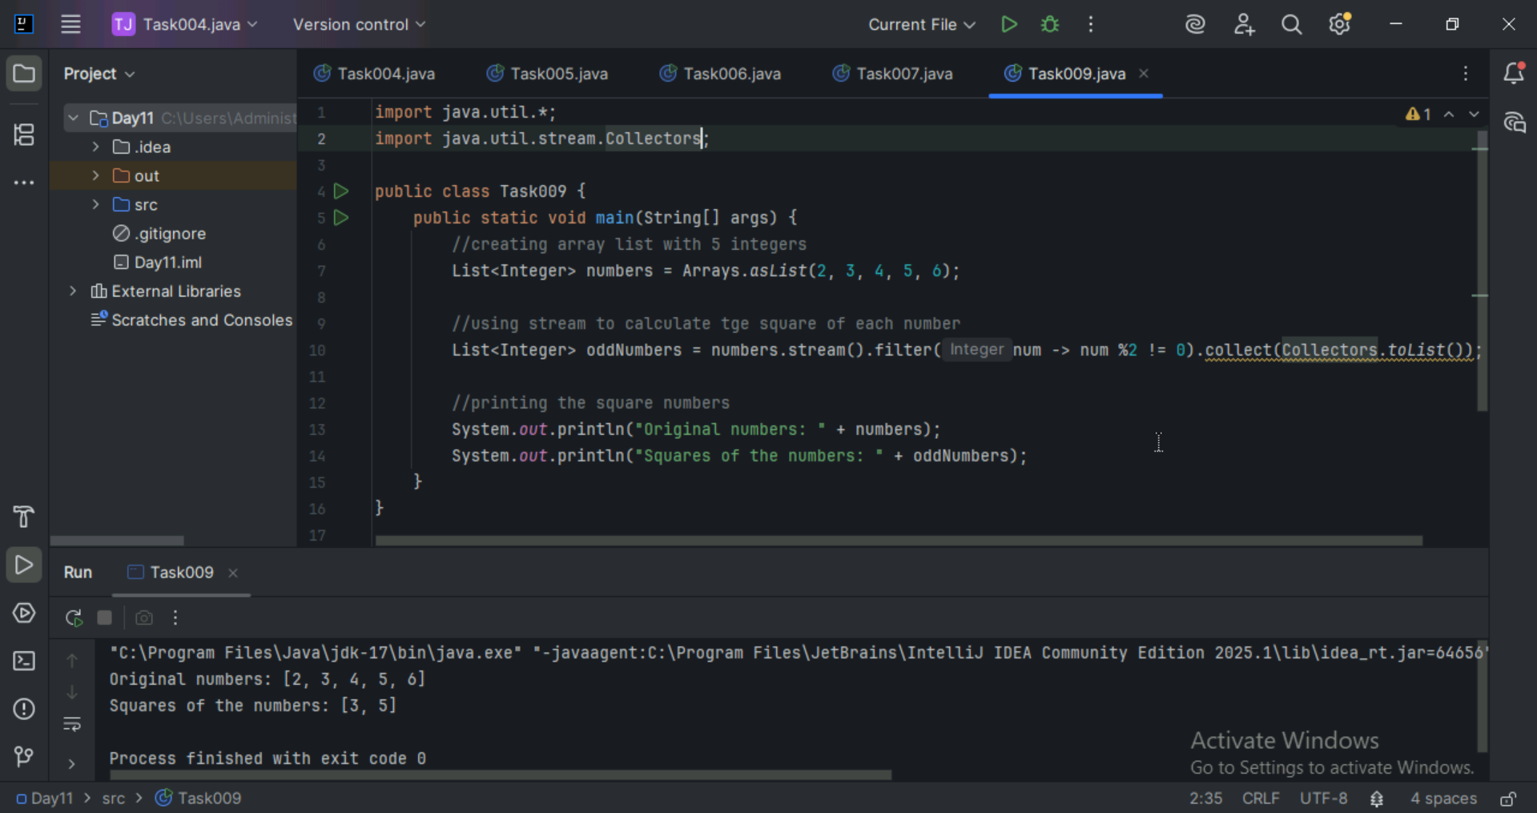

Task 10:
What do you understand by filter()?

filter() is a method used to select elements from a stream based on a condition. It takes as a function that returns true or false. It only keeps elements that returns true and returns new stream with filtered elements.

Task 11:
Wap to create an array list to remove duplicate values from the List.

Hint:
List<Integer> RemovDups= numbers.stream()
.distinct()
.collect(Collectors.toList());

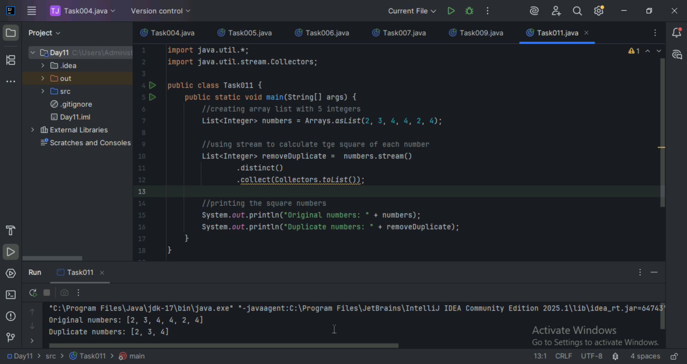

Task12:
What do you understand by distinct()?

distinct() is a method used to remove repeated elements from the stream. Returns a stream with unique elements only. This keeps the value which entered first removes the repeated one.

Task 13:
Wap to create an arrayList of your friends using string and try to sort them and display

Hint:
List<String> SortedNames= Names.stream()
.sorted()
.collect(Collectors.toList());
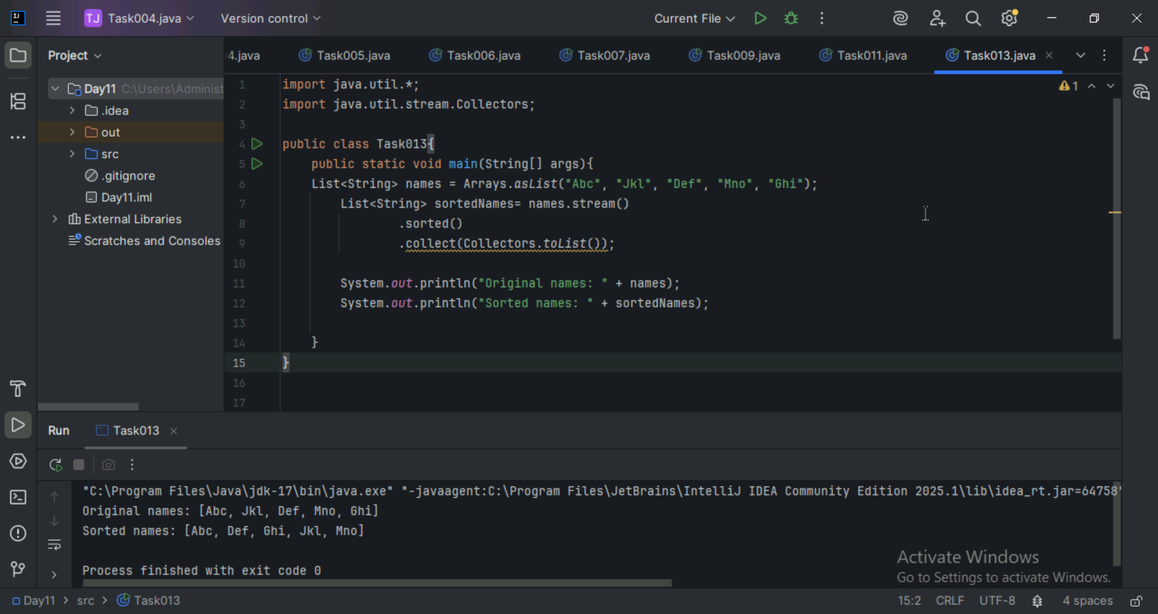

Task 14:
Wap to run a loop / iterate() and limit it to 20 values (1 to 2)
While displaying use for each to limit till 10 numbers.

Hint:
Stream<Integers> nums = Stream
.iterate(1, n -> n+1)
.limit(20);
Nums
.limit(10)
.foreach(System.out::println);
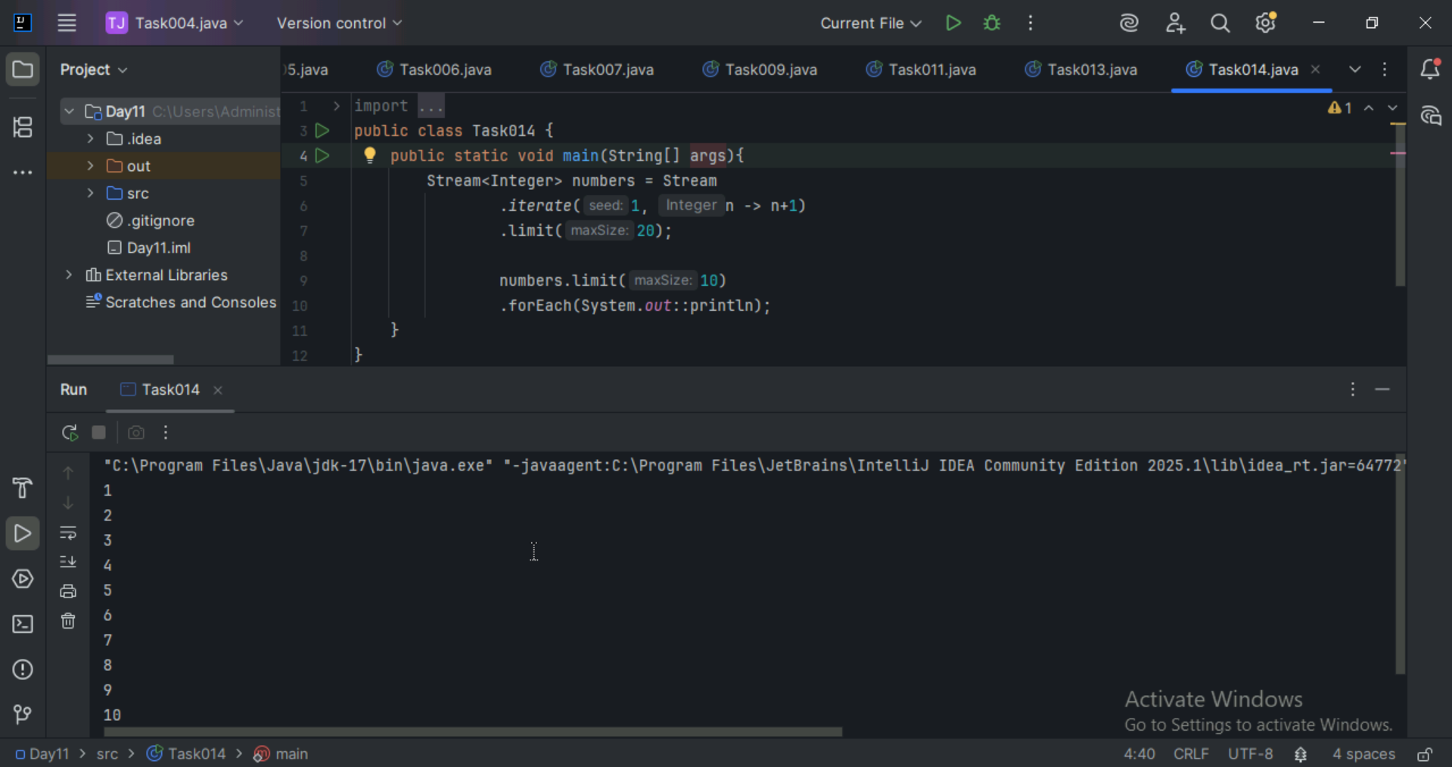

Task 15: (similar to Task 14)
Wap to create an array List skip 15 numbers and print the output using foreach loop

HInt:

Stream<Integers> nums = Stream
.iterate(1, n -> n+1)
.limit(20);

Stream<Integer> SkipNums = nums.skip(15);

Nums.foreach(System.out::println);
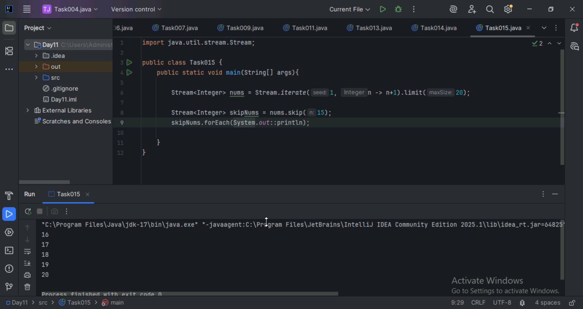

Task 16:
Explain limit and skip methods..
Limit method: This method is used to truncate a stream so that no more than n elements are processed. Ex: stream.line(n)
Skip method: This method is skips the first n elements of the stream. Ex: stream.skip(n)

Task 17:
What is the difference between mutable and immutable?

Mutable means it’s value can be changed after creation, allows modification of its internal fields.
Immutable means it cannot be changed after creation, any modification can result in a new object.
Mutable ⇒ changeable
Int

Collect ()

Immutable ⇒ cannot be changed
Wrapper classes– Integer, Long ,

reduce()

import java.util.Arrays;
import java.util.List;
import java.util.Optional;

public class ReduceExample {
public static void main(String[] args) {

List<Integer> numbers = Arrays.asList(1, 2, 3, 4, 5);

Optional<Integer> sum = numbers.stream().reduce((x, y) -> x + y);
System.out.println("Sum of all elements: " + sum.orElse(0));

Optional<Integer> max = numbers.stream().reduce(Integer::max);
System.out.println("Maximum element: " + max.orElse(0));

List<String> strings = Arrays.asList("Hello", " ", "world", "!");
Optional<String> concatenatedString = strings.stream().reduce((x, y) -> x + y);
System.out.println("Concatenated string: " + concatenatedString.orElse(""));
}
}
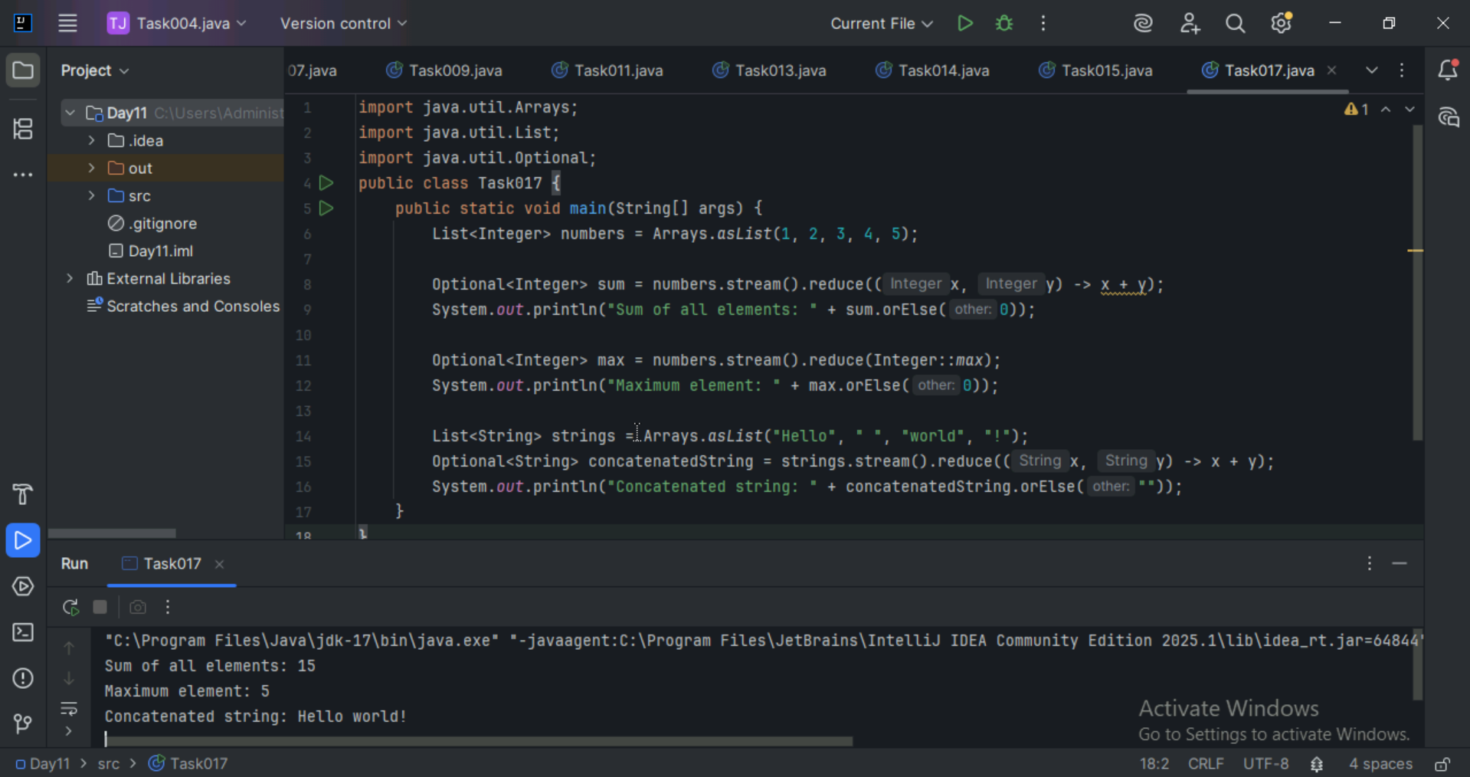

Task 18:
What are the debugging tools in Java.. list down a few.

Debugging tools helps to find and fix errors in the code, These tools allows us to inspect what your program is doing while it runs, so you can understand where it’s going wrong.

IntelliJ IDEA
Eclipse
NetBeans
Using command jdb

Task 19:
import org.apache.logging.log4j.LogManager;
import org.apache.logging.log4j.Logger;

public class Example {
private static final Logger logger = LogManager.getLogger(Example.class);

public static void main(String[] args) {
int x = 5;
int y = 7;
int sum = x + y;
logger.debug("x = " + x);
logger.debug("y = " + y);
logger.debug("sum = " + sum);
}
}

